Quarterly Report – Public Page

Date of Report: 6th Quarterly Report, June 30, 2025
Contract Number: 693JK32310010POTA
Prepared for: Government Agency: DOT and Co-funders
Project Title: Standardize the Application of Vapor Corrosion Inhibitors
Prepared by: Pipeline Research Council International (PRCI), Inc.
Contact Information: Janie Norton, jnorton@prci.org 703-205-1600 ext: 105
For quarterly period ending: June 30, 2025

1: Items Completed During this Quarterly Period:

Item # | Task # | Activity/Deliverable | Title | Federal Cost | Cost Share
17 | 3 | Analyze corrosion probe data from the VCI effect experiments | Results to be included in the quarterly report | $3,127 | $782
18 | 5 | 7th quarterly status report & project management | Submit 7th quarterly report | $7,448 | $1,862

2: Items Not Completed During this Quarterly Period:

None.

3: Project Financial Tracking During this Quarterly Period:

Note that this chart reflects Federal share only:
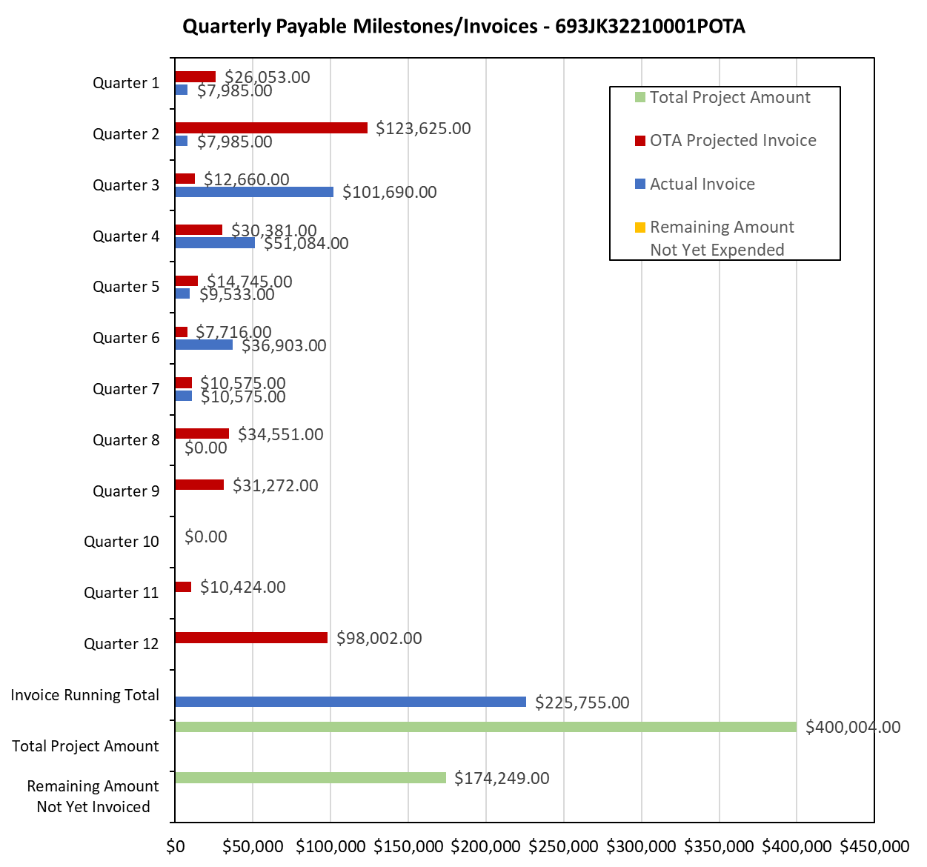

4: Project Technical Status –

Item 17, Task 3 ⎯ Analyze corrosion probe data from the VCI effect experiments. Results to be included in the quarterly report: The ER probes are being used in several tests in the VCI-effect test matrix. The various tests parameters and ER probe derived corrosion rates are listed in Table 1; it is noted that the ER probe derived corrosion rates are for 42-day duration.

Table 1. Test Parameters and ER Probe Derived Corrosion Rates in the VCI Effect Experiments
Test Parameter |  |  |  | ER Probe Corrosion rate (mpy)
Chloride  (ppm) | Nitrate  (ppm) | Moisture  (%) | VCI | ER Probe Corrosion rate (mpy)
38 | 4 | 75 | VCI-A | 0.3
244 | 23 | 75 | VCI-A | 0.01
64 | 16 | 75 | VCI-A | 3.5
0 | 423 | 75 | VCI-A | 1.4
38 | 4 | 75 | VCI-B | 0.4
244 | 23 | 75 | VCI-B | 1.1
64 | 16 | 75 | VCI-B | 1.3
0 | 423 | 75 | VCI-B | 0.7

The monitoring data indicate that VCIs are able to effectively mitigate corrosion in all but one condition; it is not clear why ER probe corrosion rates are as high as 3.5 mpy in the 65 ppm chloride and VCI-A.

This activity links to item 8 in Attachment 1 Team Project Activities. This activity links to item 10 in Attachment 2 Project Deliverables.

Item 18, Task 5 ⎯ 7th quarterly status report & project management. Submit 7th quarterly report: The sixth quarter meeting was held on June 12, 2025. This report satisfies this item. This activity links to items 11 and 13 in Attachment 1 Team Project Activities. This activity links to item 13 in Attachment 2 Project Deliverables.

5: Project Schedule –

The project is on schedule.

